Continuously Variable Tapping and Drilling Machine
Operating Instructions and Illustrations
Operating Instructions：
- Inspect if voltage is conforming prior to operation and confirm if work piece and mold have been securely located.
- Turn on the power：
Connect plug to the socket of main supply, press Power Switch in fig.1 on the control panel.
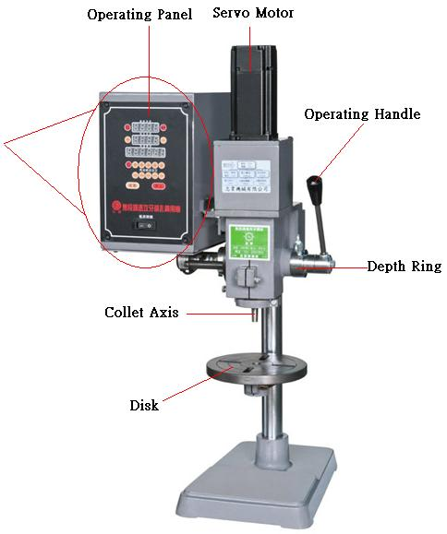
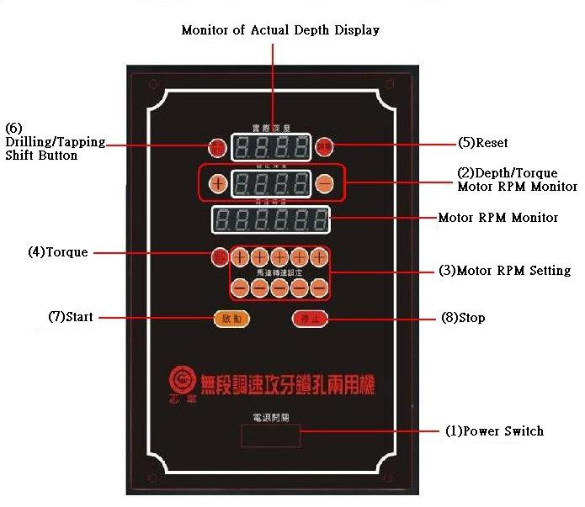
- Setting of work depth
  - Press + or – in the second row in Depth/Torque Button in fig.2 on the panel to input the work depth of work piece.
  - If depth could not be determined, press down the driller wrench to the work depth before setting as the actual depth displayed on the screen of Actual Depth on the panel.
  - Press down the wrench handle to the defined depth (actual depth monitor has same value with setting depth screen).
- Input motor rpm value
- Press + or – in [(3)Motor RPM Setting] on the panel, input rpm value as proper, the buttons of (＋)(－) from right to left correspond respectively to the single digits, tens, hundreds and thousands of motor rpm in Motor RPM Column.
- The rpm has a minimum of 200rpm, and a maximum of 3000rpm.
- Setting of torque：
  - Setting of torque: press the [(4) Torque] on the panel, and the [(2)Depth/Torque Setting] will be turned to torque setting; press + or – to input the torque value as required; press the torque button again to go back to operating page.
  - Torque should be set between 5%~100% (1.27n/m max. for motor of 400w, and 2.39n/m max. for motor of 750w).
- Reset：
Press Reset in Fig.5 on the panel to reset the work point to zero to avoid deviation of work depth.
- Shift between drilling and tapping：
In case only drilling is required without tapping in the operations, press Drilling/Tapping on the panel to shift between the modes. When drilling is on, the Depth/Torque Setting in Fig.2 in second row of the panel is inactive and there is no display on the monitor.
- Start operation：
Press [(7)Start] to start the operation, and press [(8)Stop] to stop the operation at the end of operation or in emergency case. To restart the operation, press Start.
Notices：
- Do not use porous socket, extension wire or operate several machines in the same socket to avoid damage of motor due to the low voltage.
- Do not overload in operation, it may cause overload of starter and lead to damage of controller.

