Operating instructions and illustrations for Continuously Variable Abrasive Ring Belt Grinder
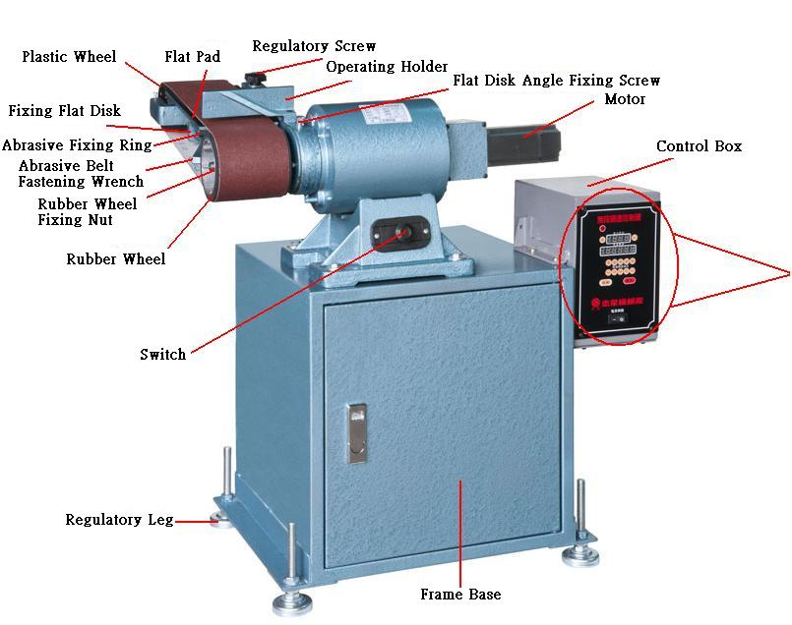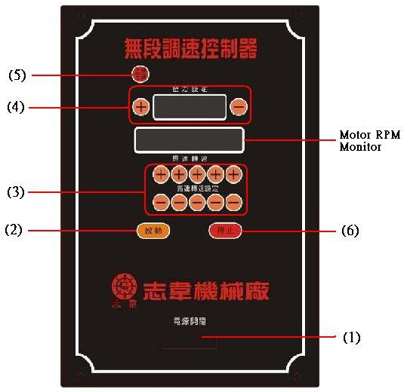
Operating Instructions：
- Inspect if the voltage is conforming and if the screws are loose before doing the operations as follow.
- Turn on the power: plug to power supply socket (do not use home extension wire), pull up the switch of abrasive grinder and press the power button on control panel (Fig.1).
- Input motor rpm value: press + or – in [(3)Motor RPM Setting] on the panel, input rpm value as proper, the buttons of (＋)(－) from right to left correspond respectively to the single digits, tens, hundreds and thousands of motor rpm in Motor RPM Column. The rpm has a minimum of 200rpm, and a maximum of 3000rpm.
- Setting of torque: press the [(4) Torque] on the panel, and the [(2)Depth/Torque Setting] will be turned to torque setting; press + or – to input the torque value as required; press the torque button again to go back to operating page. Torque should be set between 5%~100% (1.3N/M max. for motor of 400w, and 3.6N/M max. for motor of 750w)
- Start operation: press [(7)Start] to start the operation, and press [(7)Stop] to stop the operation at the end of operation or in emergency case. To restart the operation, press Start.
- Revolution and counter revolution: to shift the direction of motor revolution, press Stop button to stop the motor before pressing 『Revolution/Counter Revolution』(Fig.5)
- Adjust angle of grinding base: to elevate the abrasive ring belt, unfasten the fixing screw of flat disk angle before wrenching up the grinding base with effort (or to the desired grinding angle), then fasten the fixing screw as adequate (over-fastening may result breaking of screw or crack of rings).
- $\frac{5}{8}$Replace abrasive ring belt: To replace abrasive ring belt, pull up the fastening wrench to unfasten the abrasive ring belt, pull down the wrench again when the abrasive ring is belt replaced.
- Replace rubber wheel: to replace rubber wheel, remove the 5/8¨ fixing nut (left-threaded nut, unfasten it clockwise with effort) of rubber wheel with 26m/m socket, fasten the nut again with socket after the rubber wheel is replaced (fasten it counter clockwise).
Notices：
- Do not use porous socket, extension wire or operate several machines in the same socket to avoid damage of motor due to the low voltage.
- Do not overload in operation, it may cause overload of starter and lead to damage of controller
- Clear the dust on the grinder on a regular basis to assure the normal operations of driving and belt tension mechanism.

