Abrasive Ring Belt Surface, Disk Grinder

operating instructions
- Applications：
Operations of surface grinding, radian grinding, edging, angular grinding, rounding, square grinding, deburring, beveling, grinding, and rust removal for metals, woods, plastics and leathers.
- Features：
Abrasive ring belt could be used at any angle vertically or horizontally; and disk could be operated at any angle.
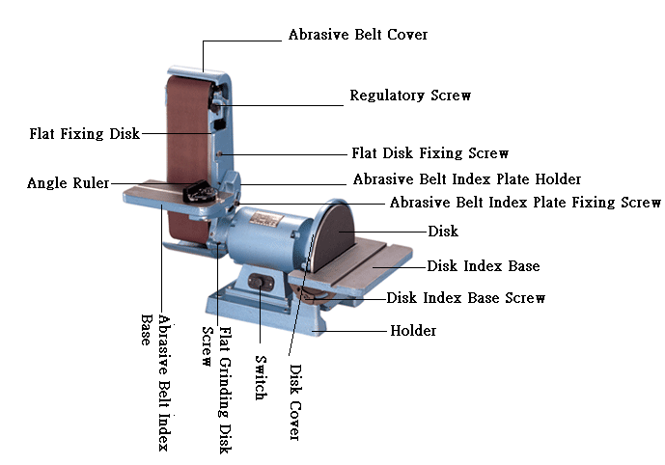
- Operating Instructions：
Inspect if the voltage is conforming and if abrasive belt and screws are loose before doing the operations as follow.
- Connect with main supply, turn on the power to see if abrasive belt runs in parallel; if abrasive belt deviates in running, regulate the abrasive ring belt to the position as adequate with regulatory screw under running status before starting operation.
- Abrasive ring belt could be operated at any angle from 0°-90°, and disk could be operated in association with flat angle disk.
- To place grinding base flat, unfasten the fixing screw of grinding base before wrenching down the grinding base flat (or to the desired grinding angle) with effort, fasten the fixing screw of grinder base as adequate (over-fastening may result breaking of screw or crack of rings).
- To replace abrasive ring belt, pull up the fastening wrench to unfasten the abrasive ring belt, pull down the wrench again when the abrasive ring is belt replaced. The disk is sized ∮12”(300m/m), and abrasive cloth could be replaced with adhesive abrasive cloth; remove the abrasive cloth to be replaced, and remove the masking paper of new abrasive cloth and stick the new one to the disk.
- To replace rubber wheel, remove the 5/8¨ fixing nut (left-threaded nut, unfasten it clockwise with effort) of rubber wheel with 26m/m socket, fasten the nut again with socket after the rubber wheel is replaced (fasten it counter clockwise).
- To adjust angle of disk index base, unfasten the fixing screws of disk index base on both sides down the index base, adjust to the desired work angle and re-fasten the fixing screws.
- Notices：
- Clear the dust on the grinder on a regular basis to assure the normal operations of driving and belt tension mechanism.
- Do not use porous socket, extension wire or operate several machines in the same socket to avoid damage of motor due to the low voltage.
- Do not overload the grinder to prevent damage to the motor due to speed down of motor and rise of voltage.

