Abrasive Cloth Disk Grinder

Operating Instructions and Illustrations
- Applications：
Operations of surface grinding, radian grinding, edging, angular grinding, rounding, square grinding, deburring, beveling, grinding, and rust removal for metals, woods, plastics and leathers.
- Features：
Disk could be operated at any angle.

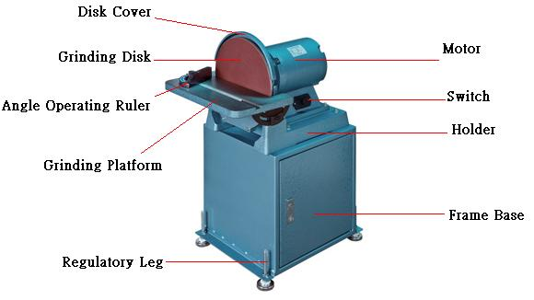
- Operating Instructions：
- Inspect if the voltage is conforming and if abrasive belt and screws are loose before doing the operations as follow.
  - Turn on the power：
Connect with main supply, turn on the power switch to start operation.

  - Replace abrasive cloth：
The disk is sized ∮12”(300m/m), and abrasive cloth could be replaced with adhesive abrasive cloth; remove the abrasive cloth to be replaced, and remove the masking paper of new abrasive cloth and stick the new one to the disk.

  - Adjust angle：
To adjust angle of disk index base, unfasten the fixing screws of disk index base on both sides down the index base, adjust to the desired work angle and re-fasten the fixing screws

- Notices：
- Clear the dust on the grinder on a regular basis to assure the normal operations of driving and belt tension mechanism.
- Do not use porous socket, extension wire or operate several machines in the same socket to avoid damage of motor due to the low voltage.
- Do not overload the grinder to prevent damage to the motor due to speed down of motor and rise of voltage.

