Continuously Variable Precision Driller Operating Instructions and Illustrations
- Applications:：
1‧Brushless motor, reducing noise pollution
2．Continuously variable design, free adjustment of rpm
二、 Function：
Applicable for drilling and tapping of mold, circuit board, clocks and watches, corals, and metal products etc.
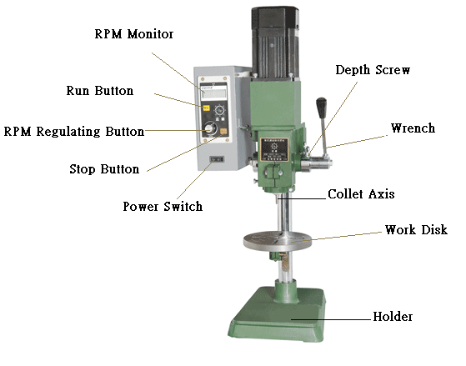
三、 Operating Instructions：
- Inspect if the voltage is conforming and if the screws are loose before doing the operations as follow.
- Install the matching collet to the collet axis and clamps the driller properly. Place mold and work pieces on the work disk as proper, and inspect if the work pieces and driller are securely located.
- Press down the wrench to the desired depth of work piece to be processed, press down the depth screw to the end and fasten the processing depth before turn on the power switch on the control box.
- Turn the RPM Button on the control box to see the rpm displayed on RPM Monitor, and adjust it to the desired rpm.
- Press the Run Button on the control panel to start the motor.
- Pull up the driller wrench to start operation.
- Press Stop Button to stop the driller at the end of operation or in emergency case.
- Clear the dust from grinder on a regular basis. Do not use porous socket, extension wire or operate several machines in the same socket to avoid damage of motor due to the low voltage.
- Do not overload the driller; the overload may slow down the motor and cause damage to it.

